**ASSIGNMENT – 3**

1. Create a new user and at the same time, you have to add that user into the group you have already created.

Ans. sudo useradd -g (groupname) (username)



1. How to unzip the bzip2 files?

Ans. By using bzip2 -d filename

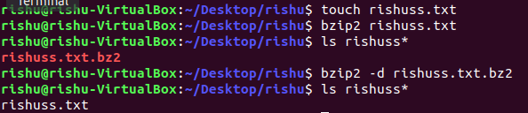

1. Archive+compress file with extension bz2 and in that, include some files with data and a folder.

Ans. tar cfvj archive.tar.bzip2 rishuss.txt

1. Add user and at the same time, change the shell of user to /bin/sh

Ans. By default, new user’s login shell is set to /bin/sh or /bin/bash. -s(--shell) allows to specify the new user’s login shell.



To verify, check using grep username /etc/passwd

